PROJECT SETUP

**\*\*\*\*\*\*\*\*\*\*\*\*\*Swagger URL\*\*\*\*\*\*\*\*\*\*\*\***

https://localhost:7206/swagger/index.html

########## DATABASE SETUP #########

1. Open your SQL Server (or preferred DBMS).
2. Locate the SQL file included in the project under the Database folder (e.g., **Database/AdFormScript.sql**).
3. Execute the SQL script to create the necessary tables (ExchangeRates, CurrencyConversionHistories, etc.) and seed initial data.
4. Update your **appsettings.json** connection string with your database details

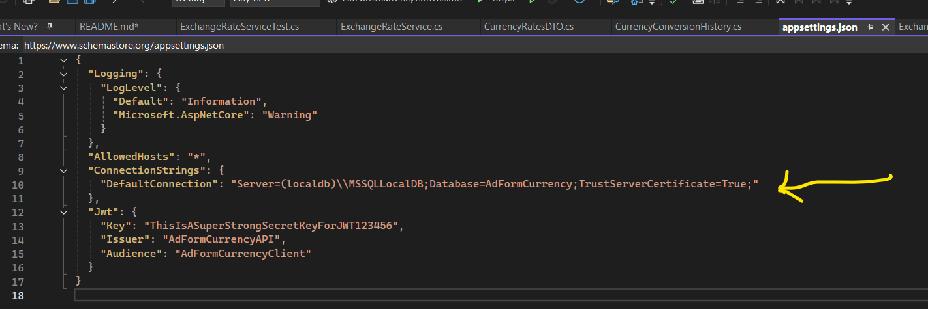

############ JWT Authentication #########

1. Run the Project
2. Default credentials for testing:

**Username: admin**

**Password: admin**

1. Use the login endpoint "/api/auth/login" to get the JWT token:

POST /api/auth/login

Body:

{

"username": "admin",

"password": "admin"

}

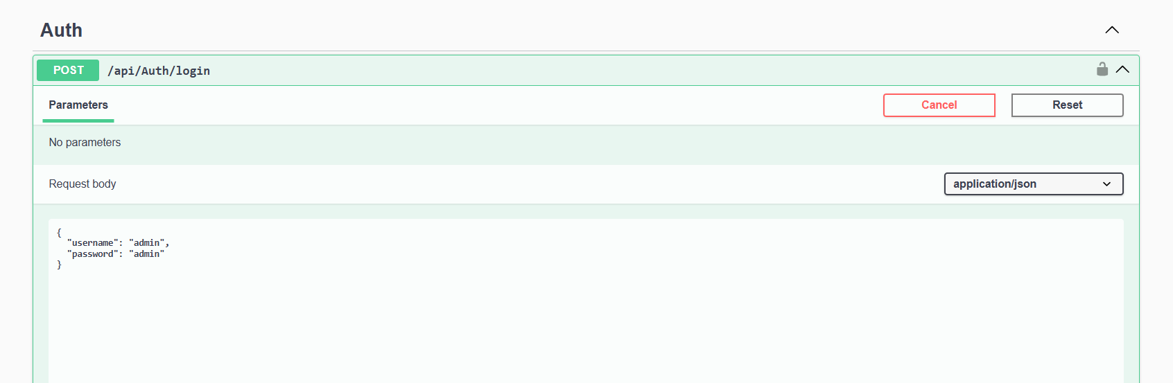

1. Copy the returned JWT token and past

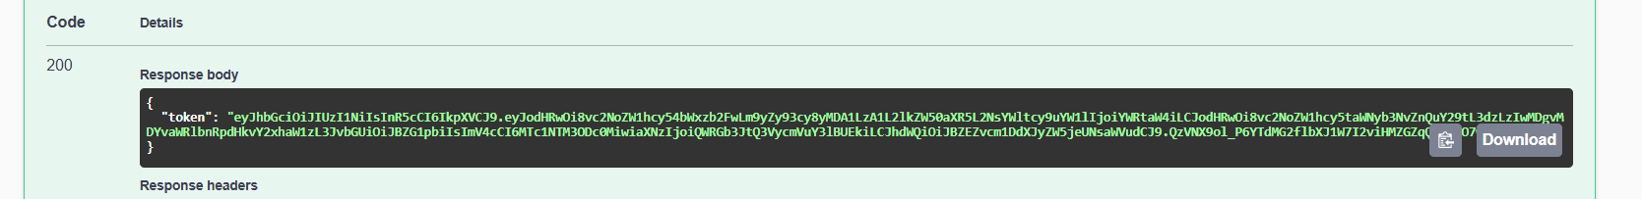

1. And paste in Authorize section of Swagger UI.

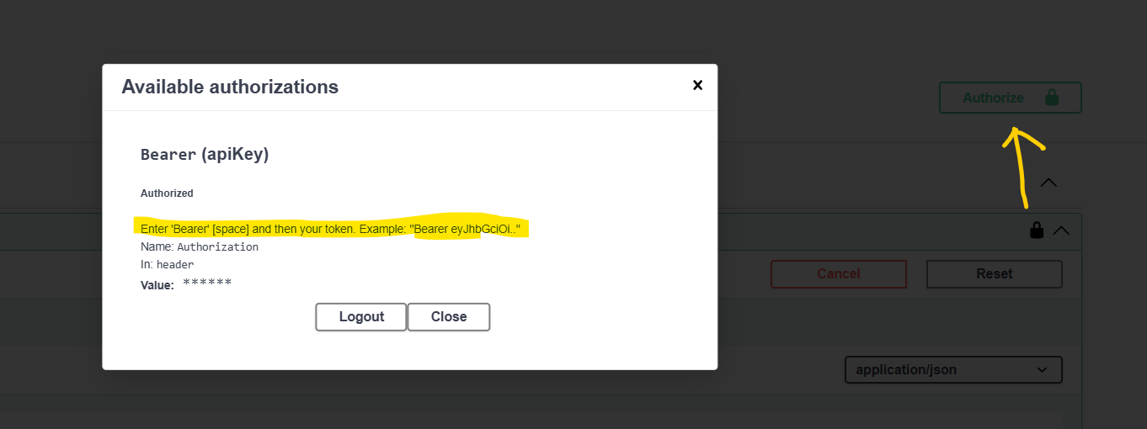

1. After this all api will authorize to access

